**PROSTATE CANCER BISPECIFIC ANTIBODY ANALYSIS RESULTS INTERPRETATION**

**Input:**

case=subset(phenoDF, **cancer=='prostate adenocarcinoma' & sample.type == 'primary'**) #select Prostate cancer control=subset(phenoDF, **biopsy.site=='PROSTATE' & sample.type=='normal'**)# select Normal Prostate data

**Output:**

Marker Pair Table before filtering (First few rows)

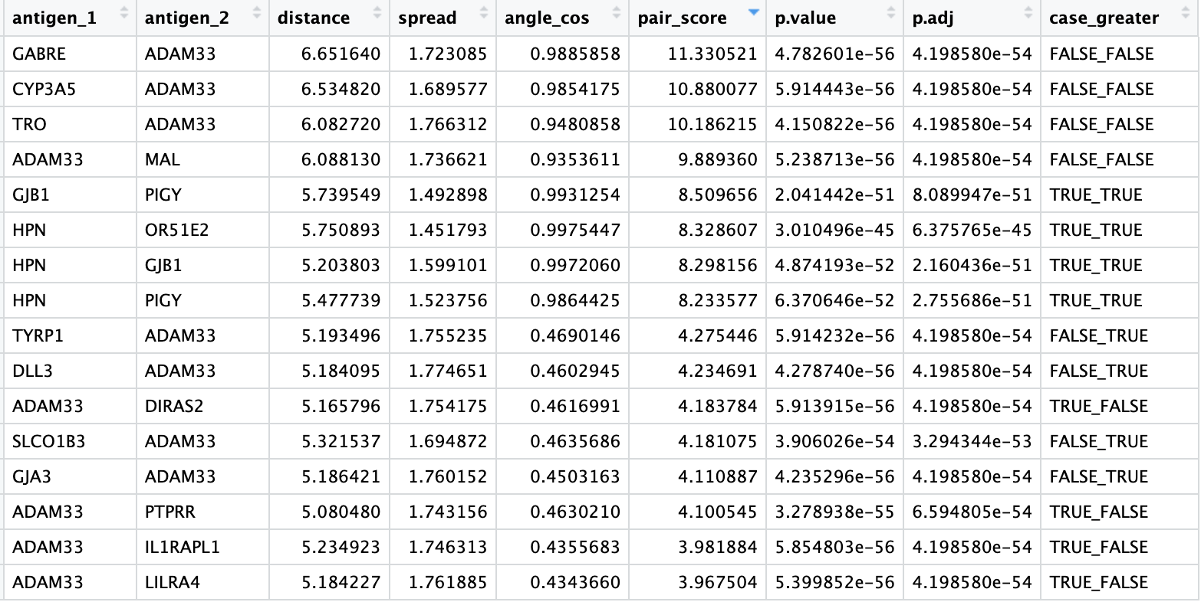

|  |  |
| --- | --- |
|  | Volcano plot showing Marker pairs. Those which are highlighted in red are highly expressed Prostate Cancer samples (case) and thus show potential to be bispecific antibody target. |

**Downstream Analysis**

After applying the cutoff criteria, 24 pair were identified as statistically significant.

small_res_sub=subset(small_res,pair_score>quantile(small_res$pair_score,.99)&case_greater=='TRUE_TRUE'&p.adj<0.01)

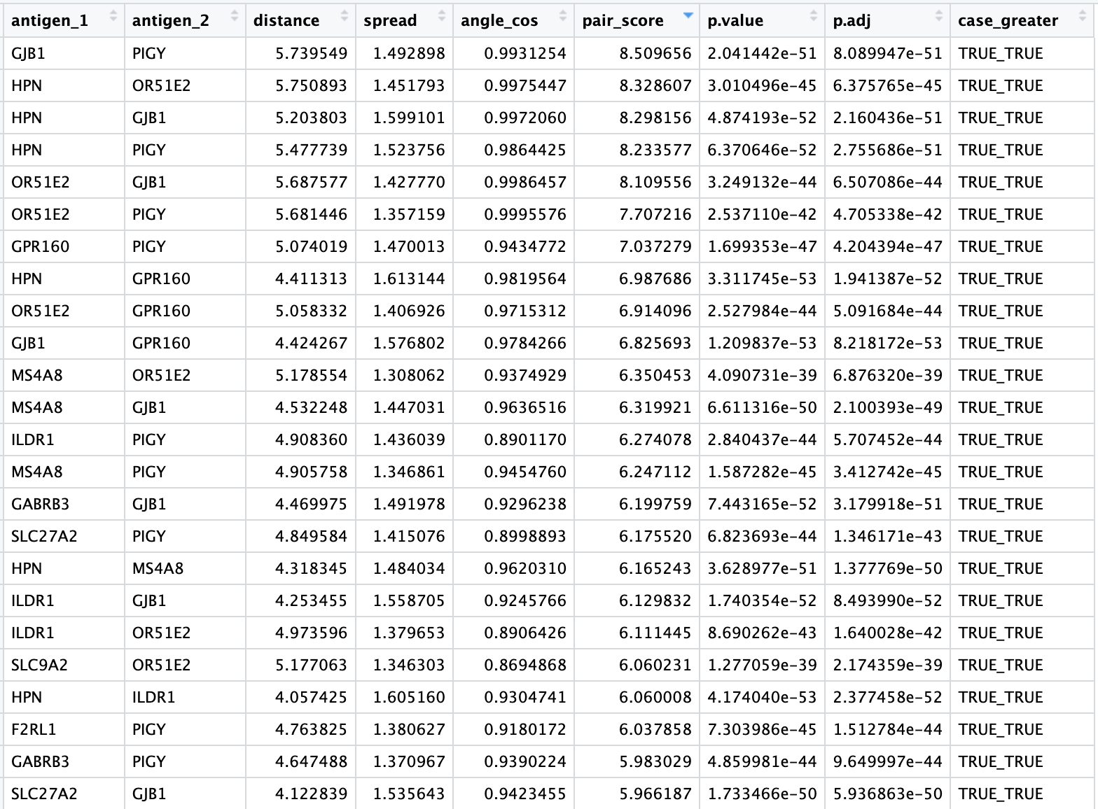

Then, we identified the top marker genes from pairs and checked their frequency.



Then, we checked the marker gene expression in healthy vital organs. Red represents case, Blue control and gray vital organs.

|  |  |
| --- | --- |
|  |  |
|  |  |

GJB1 and HPN both show higher expression in normal liver and hence the pairs including them should not be considered as bispecific antibody candidates. Whereas, ILDR1 and OR51E2 have low expression in all vital organs and thus show potential for being targeted.

Similarly, the expression of marker pair can be visualized.

|  |  |
| --- | --- |
|  |  |

Next, we checked the expression pattern of the marker genes identified by our package in single cell dataset <https://www.ncbi.nlm.nih.gov/geo/query/acc.cgi?acc=GSE141445>. We used <http://tisch.comp-genomics.org/>

For cell type annotations.

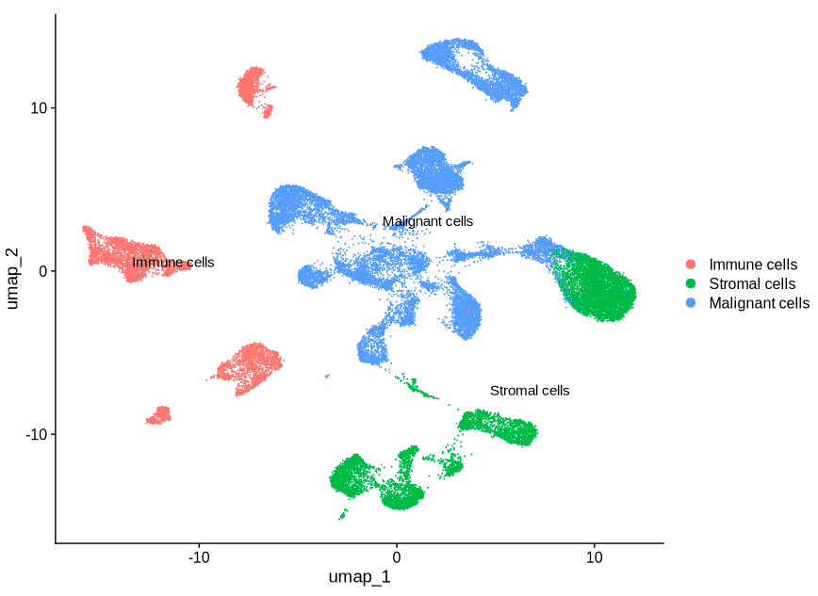 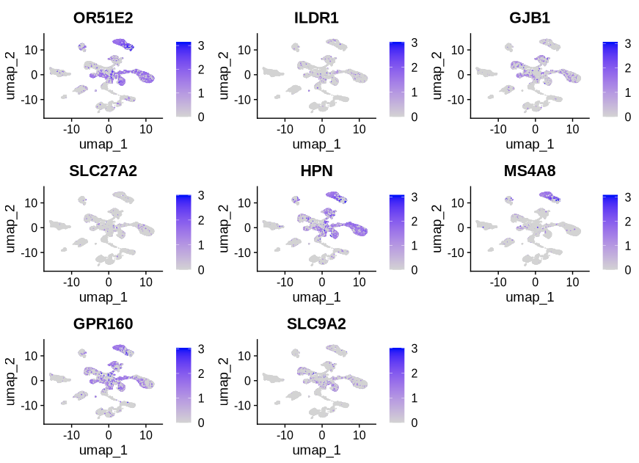

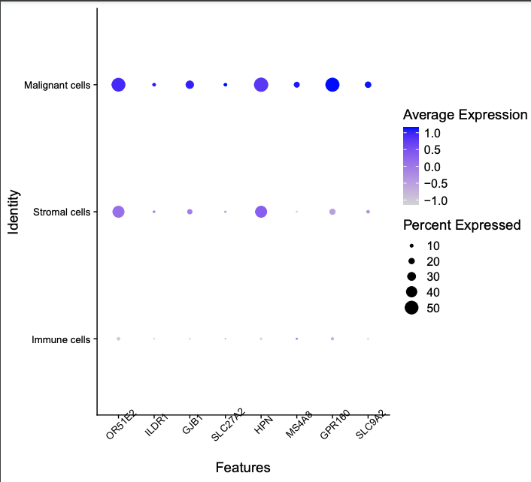

Also, we checked the expression pattern of the marker genes in healthy vital organs.

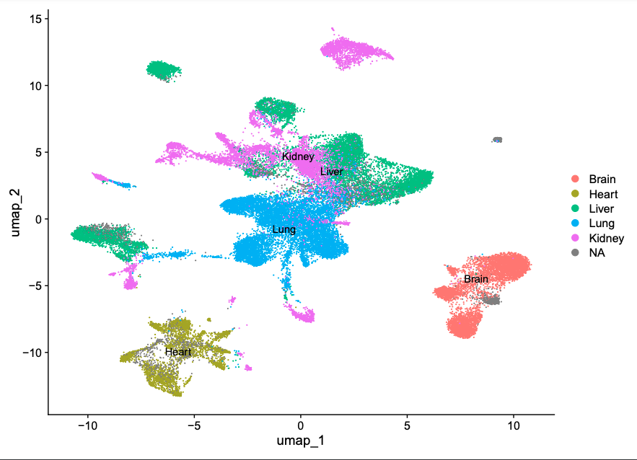 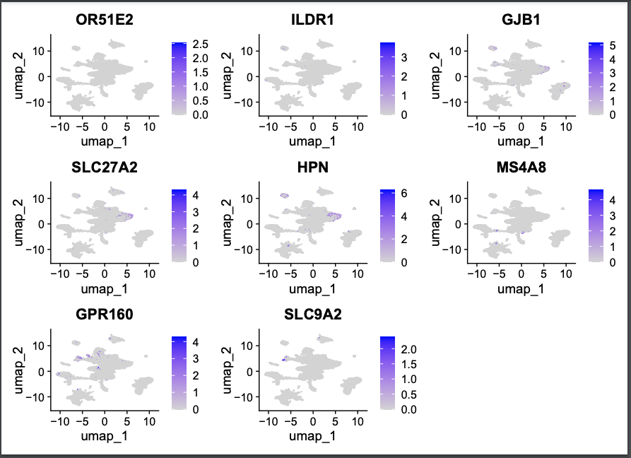

Next, we calculated the percentage of cells expressing gene A or gene B or both for given pair using sc_bispecific_expression() function.

|  |  |  |
| --- | --- | --- |
| PAIR | PRAD_GSE141445 | VITAL ORGANS |
| HPN~GJB1 |  |  |
| OR51E2~ILDR1 |  |  |

The single-cell data corroborates the findings of the bulk RNA data, showing high expression levels of HPN and GJB1 in normal liver tissue, indicating that targeting these genes should be avoided.

Reference information for OR51E2~ILDR1 marker pair

<https://www.proteinatlas.org/ENSG00000167332-OR51E2/pathology>

<https://www.proteinatlas.org/ENSG00000145103-ILDR1/pathology>

<https://pubmed.ncbi.nlm.nih.gov/33293427/>

<https://www.ncbi.nlm.nih.gov/pmc/articles/PMC9606680/>